* Network is communication system which supports many users.
* Computer Network is system which allows communication among computers in Network.
* There are certain rules to be followed to ensure proper communication , such rules are known as “ Protocol “ in data communication system.
* Interconnection of one station to many stations know as “Networking”.
* Each station in Network known as “ Node “ and connection between nodes known as “ Link ”.
* A system with one control unit (master computer) and many slaves OR a large computer with remote printers and terminals is NOT called Computer Network but it is called as DISTRIBUTED SYSTEM.

|  |  |  |
| --- | --- | --- |
| 1 | A **network system** is made up of software and associated protocols that allow a set of computer network to be used together. | A **distributed system** is an ordinary centralized operating system but runs on multiple independent CPUs. |
| 2 | Environment users are aware of multiplicity of machines. | Environment users are not aware of multiplicity of machines. |
| 3 | Control over file placement is done manually by the user. | It can be done automatically by the system itself. |
| 4 | Performance is badly affected if certain part of the hardware starts malfunctioning. | It is more reliable or fault tolerant i.e distributed operating system performs even if certain part of the hardware starts malfunctioning. |
| 5 | Remote resources are accessed by either logging into the desired remote machine or transferring data from the remote machine to user's own machines. | Users access remote resources in the same manner as they access local resources. |

* Geometrical representation of such as relationships of links and nodes is known as TOPOLOGY of that network.
* Two Types :
  + Peer to Peer : relationship where devices share the link equally ex. Ring , Mesh
  + Primary - secondary : One device controls and other device have to transmit through it. Ex. Star, Tree
* Topology :

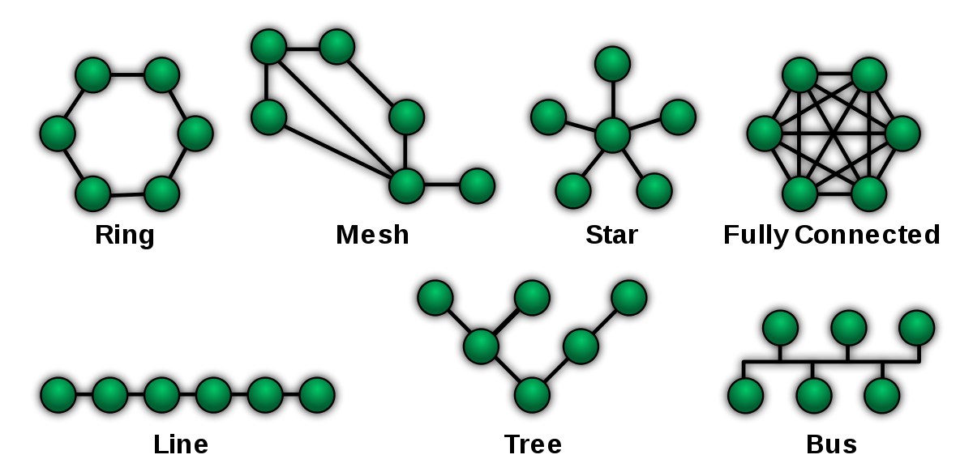

[This Photo](https://simple.wikipedia.org/wiki/Network_topology) by Unknown Author is licensed under [CC BY-SA](https://creativecommons.org/licenses/by-sa/3.0/)

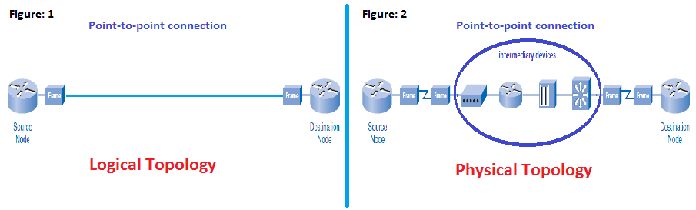

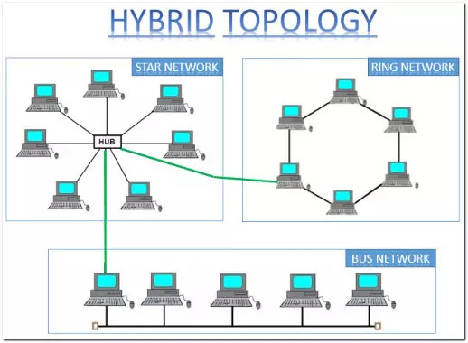

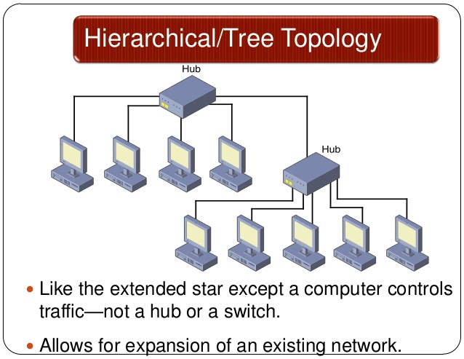

* BUS Topology :
  + Speed is slow becoz one computer can send a message at a time .A computer must wait until the bus is free before it can transmit.
  + Message is recived to every computer but accepted by one who matches destination address others rejects the message
  + Since bus is passive topology , the electrical signal is free to transfer over entire length of cable.
  + This requires proper termination at both ends of cable to avoid reflections else it returns and travels back in cable.
  + Now if transmitted and reflected waves in phase add and if they are out of phase then cancel
  + **Characterstics** :
    - **Medium Access Control (MAC)** is essential
    - Signal strength should be high to meet requirements of receiver
    - **Signal to Noise Ratio (SNR)** should be maintained
  + Transmission Media : Twisted pair cable , Baseband Co-axial ,Broadband Co-axial ,Optical fiber
  + **Adv % Disadv :** 
    - Cost less
    - High Traffic Slows network
* Ring :
  + It is used in high performance network where large bandwidth is necessary
  + Message flow around ring in one direction
  + No termination as no end is there in ring
  + Message starts to flow in ring and passed to each node if address or token matches it receives data and sends message to originator that it received message
  + Some ring networks has two counter rotating rings that helps in recover from network faults
  + **Charaterstic :**
    - Transmission is uni-directional
  + Adv & Disadv :
    - Every computer gets equal access to token
    - No standing waves produced
    - Failure of one node affects entire Network
    - Adding and removing nodes disturbs connectivity
* Star :
  + There is hub to transfer data
  + Hub can be active or passive
  + Active hub generate electrical signal and passes info to all
  + STAR LAN :
    - Unshielded Twisted Pair (UTP)
  + **Disadv :** 
    - **Hub Fails Netork Fails**
    - **Need device to switch Netork traffic**
    - **Cable cost is more**
* Mesh :
  + Every device is connected to every other device with point to point dedicated link (dedicated means Data transferred only between two devices connected on it)
  + **A Fully connected Mesh Network has n(n-1)/2 physical cables to connect n devices.**
  + **To accommodate many links every node connected to (n-1) io ports**
  + **Adv & Disadv :** 
    - Dedicated links guarantee data reliability
    - One node down , network is not down
    - Security and privacy maintained
    - Installation , reconfiguration difficult
    - Cable cost high
* Tree :
  + Central Hub fails system goes down
  + Cable cose more
* Heirarchical :
  + Divided in Layers and best one choose for each layer

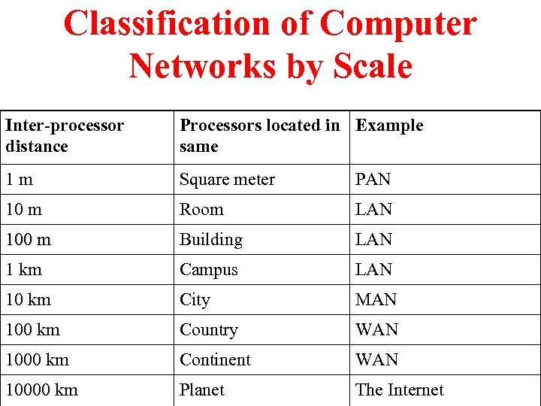

* Broadcast networks divided in tow Types
  + Static network
  + Dynamic network
* Static Network : Each machine allowed to broadcast in it’s allocated time slot
* Dynamic Network : Static allocation waste cahnnel capacity when machine does not want to transmit in its allocated time slot. Hence most of system allocate dynamically i.e. ON DEMAND
* LAN components :
  + Workstations (PC)
  + File Servers
  + Gateway
  + **Network Interfacing Unit (NIU)**
  + Active passive hubs
  + Cables
* **Asynchronous Transfer Mode ( ATM )**
* **Ethernet :**
  + **Traditinal Ethernet : 10 Mbps**
  + **Fast Ethernet : 100 Mbps**
  + **Gigabit Ethernet : 1000 Mbps**

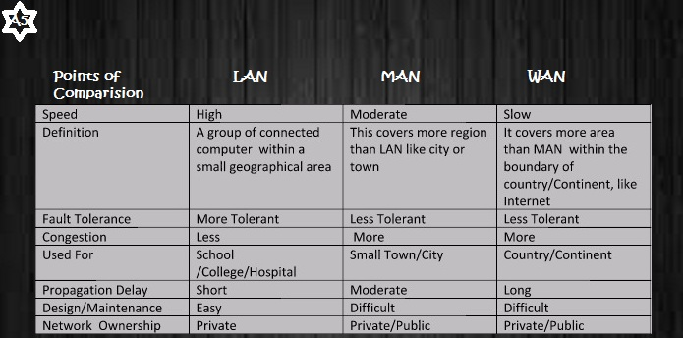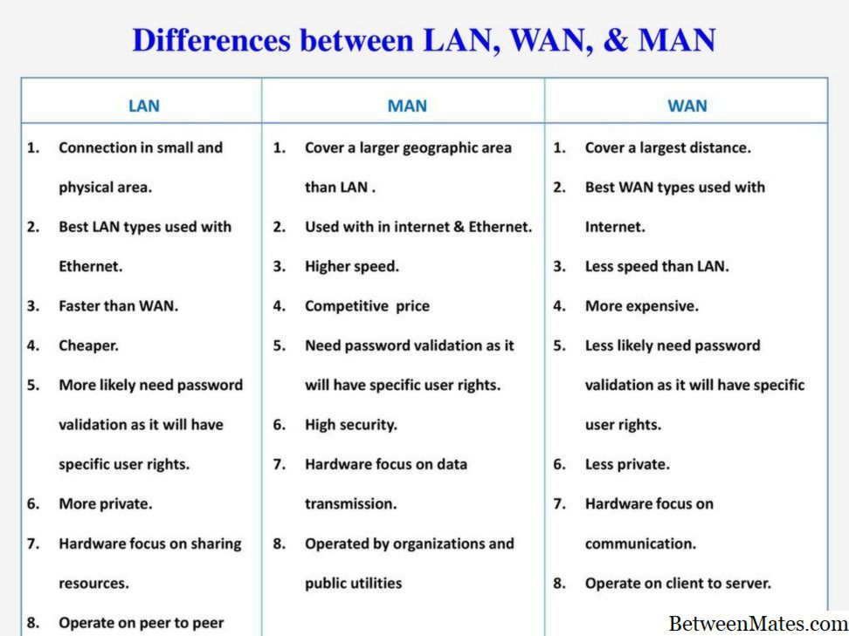

* **Ad-Hoc Network :**
  + **A group of computers can communicate to each other directly without Access Point (AP) in between**

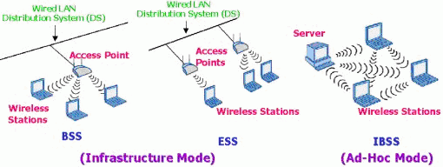

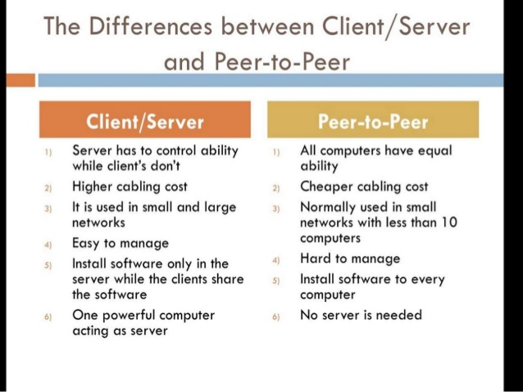

* **Software Defined Network (SDN)**